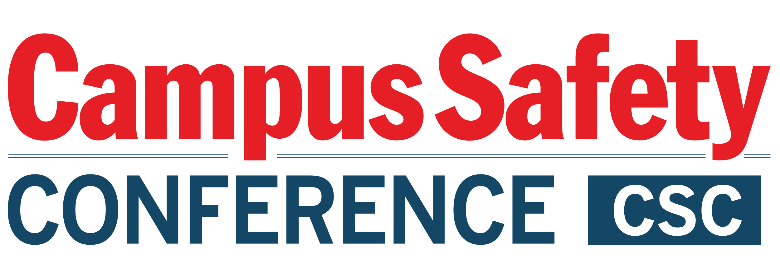

Please be sure to have materials arrive at the hotel during
the following delivery window only:
STARTING Thursday, July 14 and ENDING July 19th.

ATTN:
GUEST NAME CELLPHONE #
HOTEL GUEST ARRIVING

C/O Campus Safety Conference
The Worthington Renaissance Fort Worth Hotel
200 Main Street
Fort Worth, TX, 76102

GROUP: CAMPUS SAFETY CONFERENCE – Texas
July 18-20, 2022

BOX # OF #

Please be sure to have materials arrive at the hotel during
the following delivery window only:
STARTING Thursday, July 14 and ENDING July 19th.

ATTN:
GUEST NAME CELLPHONE #
HOTEL GUEST ARRIVING

C/O Campus Safety Conference
The Worthington Renaissance Fort Worth Hotel
200 Main Street
Fort Worth, TX, 76102

GROUP: CAMPUS SAFETY CONFERENCE – Texas
July 18-20, 2022

BOX # OF #

