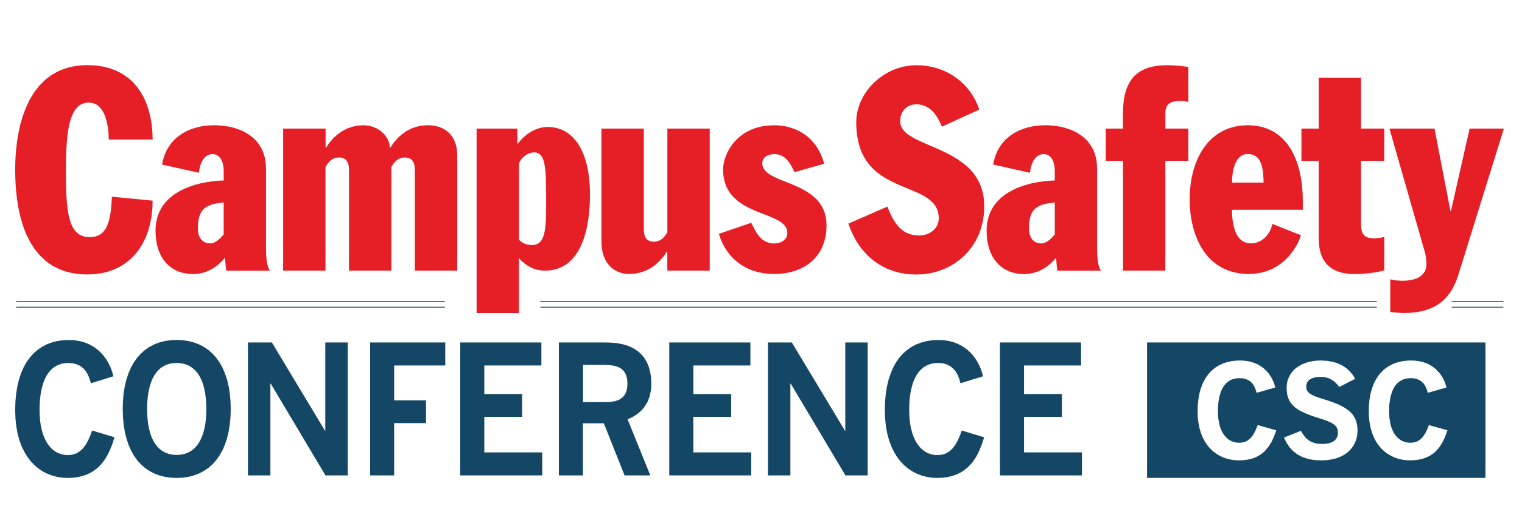

Please be sure to have materials arrive at the hotel during
the following delivery window only:
STARTING Thursday, June 16 and ENDING June 20, 2022

ATTN:
GUEST NAME CELLPHONE #
HOTEL GUEST ARRIVING

C/O Bethesda North Marriott Hotel & Conference Center
5701 Marinelli Road
North Bethesda, MD 20852
ATTN: Jessica Benz

GROUP: CAMPUS SAFETY CONFERENCE – East
June 20 – 22, 2022

BOX # OF #

Please be sure to have materials arrive at the hotel during the following delivery window only STARTING Thursday, June 16 and ENDING June 20, 2022

ATTN:
GUEST NAME CELLPHONE #
HOTEL GUEST ARRIVING

C/O Bethesda North Marriott Hotel & Conference Center
5701 Marinelli Road
North Bethesda, MD 20852
ATTN: Jessica Benz

GROUP: CAMPUS SAFETY CONFERENCE – East
June 20 – 22, 2022

BOX # OF #

