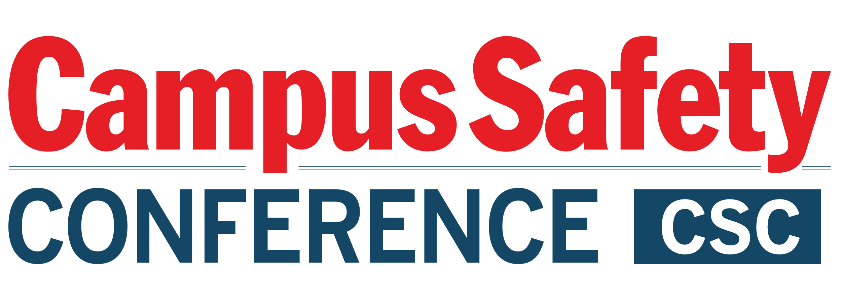

Please be sure to have materials arrive at the hotel during the following delivery window only: STARTING FRIDAY, JULY 29 and ENDING AUGUST 3rd, 2022

To:
GUEST NAME CELLPHONE #
HOTEL GUEST ARRIVING

C/O Tracey Perfetti (hotel CSM)/Rio Grande Ballroom
The Westin Bonaventure Hotel & Suites
404 South Figueroa Street
Lost Angeles, California 90071

GROUP: CAMPUS SAFETY CONFERENCE – West
August 2-4, 2022

BOX # OF #

Please be sure to have materials arrive at the hotel during the following delivery window only: STARTING FRIDAY, JULY 29 and ENDING AUGUST 3rd, 2022

To:
GUEST NAME CELLPHONE #
HOTEL GUEST ARRIVING

C/O Tracey Perfetti (hotel CSM)/Rio Grande Ballroom
The Westin Bonaventure Hotel & Suites
404 South Figueroa Street
Lost Angeles, California 90071

GROUP: CAMPUS SAFETY CONFERENCE – West
August 2-4, 2022

BOX # OF #

