ICS Form 201

Action Plans |  | 1. Incident Name  Fire Drill | 2. Date Prepared | 3. Time Prepared
4. Map Sketch
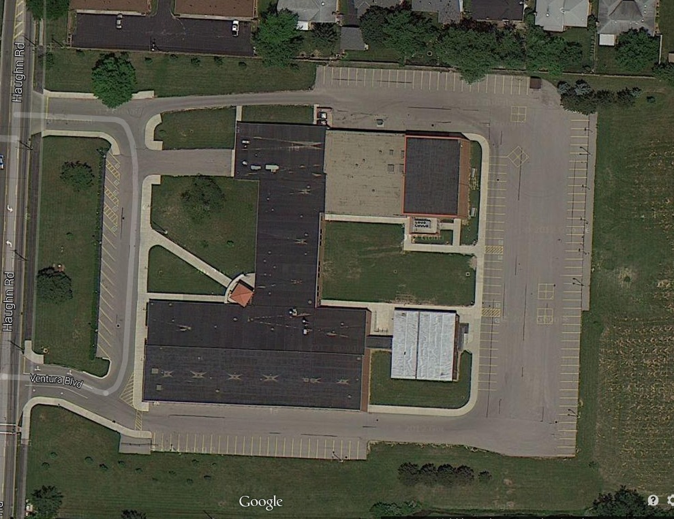
CP
Area A

Command Post (CP) – Maureen Veeley and Michael Nesler report for attendance.

Area A – Nancy Leonhard and Jo Jones report for attendance.
Classrooms: Numbers 1-20 are painted in yellow at the back of the parking lot under the basketball hoops/recess area. All classrooms report to Area A and are assigned a numeric location.
For the 2015-2016 school year, the following classrooms are assigned to the following numeric spots:

1 2 3 4 5 6 7 8 9 10 11 12 13 14 15 16 17 18 19

110 112 113 117 173 176 175 178 184 185 186 192 193 172 170 165 162 155 153
ICS 201  Page 1 of 2 | 5. Prepared by (Name and Position)  Michael Nesler, Incident Commander

Standard Operating Procedures
- Any Staff member who believes there is a danger from fire, smoke, or a chemical release in the building is authorized to activate the fire alarm to evacuate the building. As soon as possible, the staff member will notify an administrator of the event leading to the evacuation.
- Staff members in a class will proceed to the nearest exit with their students. Staff members will take their class roster to take attendance. Staff members will take their students to the designated area in the rear of the school grounds.
- Staff and students in the cafeteria due to lunch or BCO will evacuate the building to Area A If lunch is in progress, it is more important to make sure all students have exited the building than to attempt taking attendance. One staff member will be the last to leave the area and make sure the cafeteria is vacant. That staff member will report to the Incident Commander the areas are cleared.
- If an alarm is pulled during class change, staff members will clear their classrooms and the hallways, directing students to the teacher’s assigned area outside for attendance.
- Teachers who are on their Planning Period will always be the last staff members out of the building. These staff members will be assigned restrooms and building areas to check before exiting the building. As soon as these staff members have exited the building they will report to the Incident Commander that the building is clear. If, due to the nature of the event, the staff members must exit the building before checking their assigned area, this will be reported to the Incident Commander so the Fire Department can enter and search the areas. In the event the alarm is pulled during class change, staff members who will be on Planning Period next are responsible for sweeping their areas for students.
- Once all students and staff members have exited the building, attendance will be taken by staff members in class at the time of the evacuation. Missing students will be reported to the persons responsible for the area.
- The custodian will be responsible for directing traffic at the entrance of the school and establishing the Command Post.
- The school nurse/med monitor will remove the medicines from the clinic and take them to the Command Post.
- In the event of an extended drill/event that require students and staff to remain outside during inclement weather, after attendance and if possible, everyone will proceed to secondary evacuation centers. Staff members will be placed in an assigned area and must stay with their students. Secondary evacuation centers could be the Pre-school center and JC Sommer Elementary.
- No one will be allowed back in the building until given the “All Clear” by the incident commander.
- An After Action Review will be conducted after each drill to review procedures and recommend changes when needed.

ICS 201 | Page 2

Incident Action Plan ICS 214

UNIT LOG |  | 1. Incident Name  Fire Drill |  | 2. Date Prepared |  | 3. Time Prepared
4. Unit Name/Designators |  | 5. Unit Leader (Name and Position) |  |  |  | 6. Operational Period
7. Personnel Roster Assigned
Name |  |  | ICS Position |  | Contact Numbers
Michael Nesler |  |  | Incident Commander |  | 614-555-1212
Maureen Veeley |  |  | Deputy Commander |  | 614-555-1212
Jo Jones |  |  | Resources |  | 614-555-1212
Francie Manukian |  |  | First Aid |  | 614-555-1212
Tara Pendleton |  |  | Student Care |  | 614-555-1212
Barb White |  |  | Student Care |  | 614-555-1212
Kristi Gagliardi |  |  | Student Care |  | 614-555-1212
Casie Elander |  |  | Student Care |  | 614-555-1212
George Buck |  |  | Safety |  | 614-555-1212
Michelle Walker |  |  | Safety |  | 614-555-1212
Nancy Leonhard |  |  | Accountability |  | 614-555-1212
Sharon Aliff |  |  | Accountability |  | 614-555-1212
Brad Jasin |  |  | Accountability |  | 614-555-1212
Phil Dugal |  |  | Accountability |  | 614-555-1212
8. Activity Log
Time | Major Events
9. Prepared by (Name and Position)
Michael Nesler, Principal

Incident Action Plan Safety & Risk Analysis Form, ICS 215A
INCIDENT ACTION PLAN SAFETY ANALYSIS | 1. Incident Name |  |  |  | 2. Date | 3. Time
Area |  | Potential Hazards |  |  | Mitigations (e.g., PPE, buddy system, escape routes)
 |  | Type of Hazard: | Type of Hazard: | Type of Hazard:
Students with limited mobility (temporary). |  |  |  |  | Classroom teacher is responsible for the evacuation of that child.
Prepared by (Name and Position) Michael Nesler, Principal

