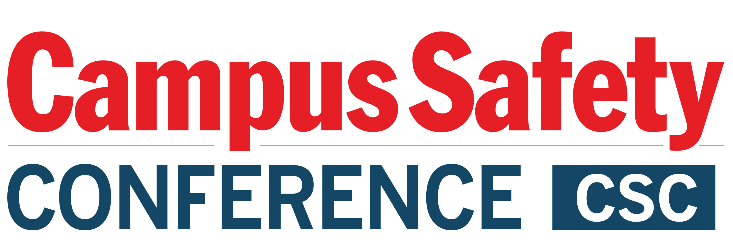

Please be sure to have materials arrive at the hotel during the following delivery window only: STARTING THURSDAY, JULY 15, AND ENDING MONDAY, JULY 19, 2021.

To:
GUEST NAME CELLPHONE #
HOTEL GUEST ARRIVING

C/O FedEx Office at
SAN ANTONIO MARRIOTT RIVERCENTER
101 Bowie St
San Antonio, TX 78205

Phone: 210.248.0760 Fax: 210.227.4878 Email: usa1278@fedex.com

GROUP: CAMPUS SAFETY CONFERENCE – TEXAS
JULY 21-23, 2021

BOX # OF #

Please be sure to have materials arrive at the hotel during the following delivery window only: STARTING THURSDAY, JULY 15, AND ENDING MONDAY, JULY 19, 2021.

To:
GUEST NAME CELLPHONE #
HOTEL GUEST ARRIVING

C/O FedEx Office at
SAN ANTONIO MARRIOTT RIVERCENTER
101 Bowie St
San Antonio, TX 78205

Phone: 210.248.0760 Fax: 210.227.4878 Email: usa1278@fedex.com

GROUP: CAMPUS SAFETY CONFERENCE – TEXAS
JULY 21-23, 2021

BOX # OF #

