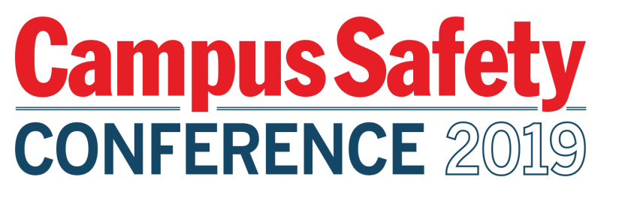

Please be sure to have materials arrive to the hotel
NO EARLIER THAN THURSDAY, JUNE 13, 2019

To:
SPONSOR POC NAME
SPONSOR COMPANY NAME

C/O THE M RESORT SPA AND CASINO

GROUP: CAMPUS SAFETY CONFERENCE WEST -
JUNE 17-19, 2019

12300 S LAS VEGAS BLVD

HENDERSON, NV 89044

TABLE #
BOX # OF #

Please be sure to have materials arrive to the hotel
NO EARLIER THAN THURSDAY, JUNE 13, 2019

To:
SPONSOR POC NAME
SPONSOR COMPANY NAME

C/O THE M RESORT SPA AND CASINO

GROUP: CAMPUS SAFETY CONFERENCE WEST -
JUNE 17-19, 2019

12300 S LAS VEGAS BLVD

HENDERSON, NV 89044

TABLE #
BOX # OF #

