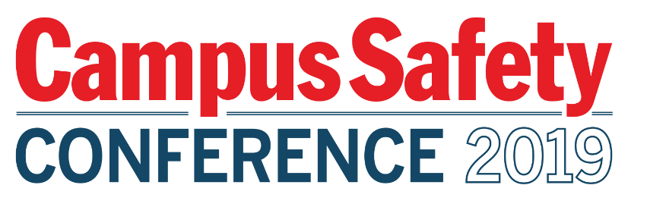
Please be sure to have materials arrive to the hotel
ON WEDNESDAY, JULY 17, 2019

To:
SPONSOR POC NAME
SPONSOR COMPANY NAME
C/O OMNI MANDALAY HOTEL AT LAS COLINAS

HOTEL CONTACT: RENEE REAGAN
GROUP: CAMPUS SAFETY CONFERENCE – TEXAS
JULY 21-23, 2019

221 EAST LAS COLINAS BLVD

IRVING, TX 75039

TABLE #
BOX # OF #

Please be sure to have materials arrive to the hotel
ON WEDNESDAY, JULY 17, 2019

To:
SPONSOR POC NAME
SPONSOR COMPANY NAME
C/O OMNI MANDALAY HOTEL AT LAS COLINAS

HOTEL CONTACT: RENEE REAGAN
GROUP: CAMPUS SAFETY CONFERENCE – TEXAS
JULY 21-23, 2019

221 EAST LAS COLINAS BLVD

IRVING, TX 75039

TABLE #
BOX # OF #

