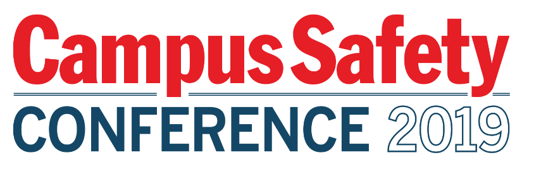
Please be sure to have materials arrive to the hotel
ON THURSDAY, AUGUST 1, 2019
TO: EMBASSY SUITES BY HILTON CHARLOTTE-
CONCORD GOLF RESORT & SPA

ATTN: SCOTT BIRCKHEAD, EVENT SALES
5400 JOHN Q. HAMMONS DRIVE NW

CONCORD, NC 28027

GROUP: CAMPUS SAFETY CONFERENCE - EAST
AUGUST 6-8, 2019

HOLD FOR
SPONSOR POC NAME
SPONSOR COMPANY NAME

TABLE #
BOX # OF #

Please be sure to have materials arrive to the hotel
ON THURSDAY, AUGUST 1, 2019
TO: EMBASSY SUITES BY HILTON CHARLOTTE-
CONCORD GOLF RESORT & SPA

ATTN: SCOTT BIRCKHEAD, EVENT SALES
5400 JOHN Q. HAMMONS DRIVE NW

CONCORD, NC 28027

GROUP: CAMPUS SAFETY CONFERENCE - EAST
AUGUST 6-8, 2019

HOLD FOR
SPONSOR POC NAME
SPONSOR COMPANY NAME

TABLE #
BOX # OF #

